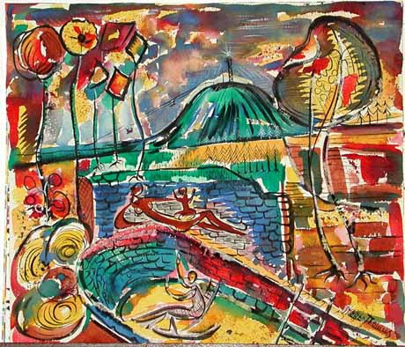
Stone Mountain with Monument Mother Earth by Steffen Thomas

Healing Our Humanity: Finding Hope, Love and Unity
A Juried Exhibition at the Steffen Thomas Museum of Art
March 4 – June 4, 2021

The Steffen Thomas Museum is inviting artists of all media and genres to apply for its annual juried exhibition

ABOUT THE EXHIBITION:

THE THEME of this year’s exhibition is Healing our Humanity: Finding Hope, Love and Unity

“The most important aspect of art is communication. I use universal themes and I try to communicate with all persons. Art is unique in that a translation is not necessary, and a genuine work of art can be more powerful than a dozen ambassadors. If we can exchange our ideas and our feelings through art, I think it will be a little more difficult for us to go shooting and dropping bombs on each other. Perhaps I am an idealist, but this is what I believe and this is the purpose of my work.”

- Steffen Thomas, November, 1965 from The Turbulent World of Steffen Thomas by Richard Ainsworth as published in ‘ATLANTA’ The Official Publication of the Atlanta Chamber of Commerce.

Ironically, the political climate and social issues we face now are not so different than those occurring when Thomas gave this interview in 1965. The next chapter for our fiercely divided nation is uncertain and moreover unsettled. The one thing we do know is that there are wounds that need healing and effort required from everyone to return our country to unity.

For decades, the works of Steffen Thomas expressed the idea of all people belonging to a single family of man, without regard to race, gender, or any other label. Thomas often expounded “Families need to communicate – even families of man. It seems that not enough do.”

This show aims to compile a broad range of perspectives that tell the dynamic story of our current social climate. We seek to feature a group of artists whose work inspires communication, healing, hope, love and unity.

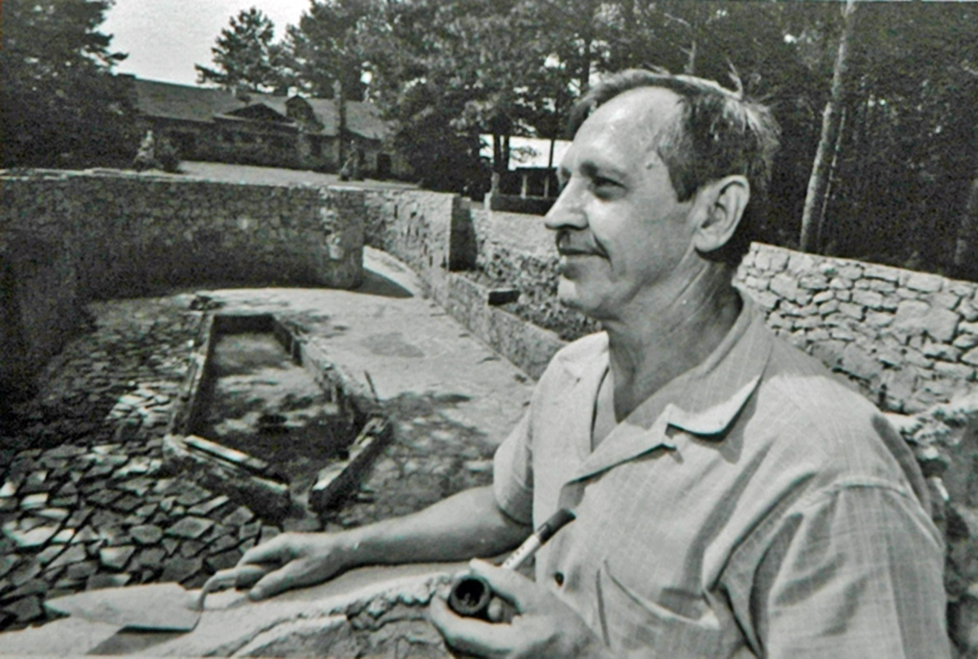
Steffen Thomas ca 1960, at work on Monument to Mother Earth at his Stone Mountain home/studio

ABOUT THE ARTIST

Steffen Thomas (1906 – 1990)

Steffen Thomas was born in Fürth, Germany in 1906 and had a dream from childhood of becoming an artist, specifically a sculptor. He was trained in classical sculpture at the Academy of Fine Art in Munich from 1924 – 1928, achieving Master status at the age of 21. Thomas immigrated to the US in 1928 and settled in Atlanta by 1930. Most of his professional career as an artist was centered in the Atlanta area, and he had a long career as a sculptor creating many public works of art that can be found in Atlanta and the Southeast. His last studio was in Midtown Atlanta, and after his widow Sara Douglass Thomas found it impossible to establish a studio museum on the site of the last studio, she decided to build on land owned by Steffen Thomas, Jr. in rural Morgan County, near Madison, Georgia.

Steffen Thomas Museum of Art

The Steffen Thomas Museum of Art is a single-artist museum located near Madison, Georgia dedicated to the life and art of Georgia Master artist Steffen Thomas. The Museum offers a multitude of arts outreach programs to the residents of Northeast and Middle Georgia. STMA displays a large collection of Steffen Thomas art, including sculpture, paintings, furniture and works on paper. For more information see www.steffenthomas.org

Additional Research Materials:

CHRONICLE OF A WORKING ARTIST 1930-1977

CHRONICLE OF A WORKING ARTIST 1977-1996 Vol. II

Steffen Thomas - The Freedom of The Figure by Andrew Hayes & Alan Aiches

The Art of Steffen Thomas by Anthony F. Janson

Steffen Thomas Rediscovered – Ogden Museum of Southern Art

Steffen Thomas: No Less Than Truth
https://www.youtube.com/watch?v=g3Jao0ibRr0&feature=youtu.be

All research materials are available for review at the Steffen Thomas Museum of Art by appointment. Certain materials may be available for purchase. Please call 706.342.7557 or email info@steffenthomas.org for an appointment.

ABOUT THE JUROR

September Gray’s life’s work reflects her enduring passion for the arts. Following a noteworthy career in the performing arts, Gray launched a successful fine art consultancy practice wherein she was celebrated for her ability to assist corporate and private collectors with articulating and executing single acquisition and long–term collecting strategies.
Gray’s career in the arts and decade as an art consultant inform her role as gallerist. An avid collector, Gray has a talent for “speaking the language” of both artist and collector and a knack for connecting the gallery’s clients to works by artists whose vision and methodologies resonate with their individual tastes, complement their existing collections and honor their overall investment strategy and appetite for risk.
Gray holds a B.A. in Art History from DePaul University. A committed art education advocate, Gray serves on a number of non-profit boards and is co-founder of The Gray Foundation, an organization committed to building a world of enriched life options for youth through the promotion of art and education. Gray shares art news and collection strategies in her electronic quarterly journal, The Gray Book.

Criteria for Art Submitted for Exhibition

- Original works of art must include subject matter or themes inspired by Healing Our Humanity: Finding Hope, Love and Unity.
- Paintings must be framed or “gallery wrapped” and wired for hanging. (No saw tooth hangers.) Artist’s name and contact information must be affixed to the back of work.
- Artists may submit up to four works of art for consideration.
- Works for consideration may be already completed or be a narrative of proposed work to be completed prior to the exhibition opening.
- All submissions should include artist information form, bio, dimensions, high res images, and brief narrative describing the work’s relevancy to theme.
- Email submissions to info@steffenthomas.org prior to December 15, 2020. Please include “Healing Our Humanity” in the subject line.
- Our guest juror will choose up to 5 artists to participate.
- STMA Loan Forms will be distributed to selected artists via email. Loan forms must be filled out completely and include an insured value of the art work, description of the work, title, and artist contact information. Artists wishing to sell their works during the exhibition must indicate this on their loan form. Pricing for works will be the listed insured value indicated on the loan form. All sales will be handled by STMA staff, and a 30% commission will be taken by STMA for any work sold.

EVENT CALENDAR

December 15: Submissions Due

January 7: Artist Selection Announcement

March 4: Virtual Opening and continuous viewing through June 4

March 4 – June 4: Appointments accepted during regular museum hours for private, socially distanced, in-person docent or Steffen Thomas family member tours ($150)

March 4: Virtual Curator/Juror Talk

April 3: Virtual Artist Interviews and/or Panel Discussion

May 6: Virtual Gallery Talk on Steffen Thomas’s philosophy

June 4: Exhibition Close

Note: Additional ‘in-person’ events may be added if COVID conditions resolve.

Steffen Thomas Museum of Art Juried Exhibition
March 4 – June 4, 2021

Artist Information Form

Artist Name_______________________________________________________________

Address__________________________________________________________________

City____________________________________State____________Zip_______________

Phone (home) ____________________________(Cell)_____________________________

E-mail____________________________________________________________________

Website___________________________________________________________________

Social Media Accounts __________________________________________________________________________
(Instagram, Facebook, etc.)

AGREEMENT WITH STEFFEN THOMAS MUSEUM OF ART
(Signature required)

By entering this STMA Juried Exhibition, I affirm that I have read this entire agreement, and by signing this entry form I agree to be bound by all terms outlined in it. I understand that I will facilitate the pickup and drop-off of my own work. I understand a condition report will be conducted before the work is installed and I will sign upon installation and de-installation. I understand my work can be sold while it is exhibited at the Steffen Thomas Museum of Art, that all sales will be handled by STMA staff; and I agree to pay a 30% commission to STMA for any work sold at STMA. I also agree that images of work that is exhibited may be used by STMA for publicity purposes.

Signature________________________________________________________

Date_________________________________

